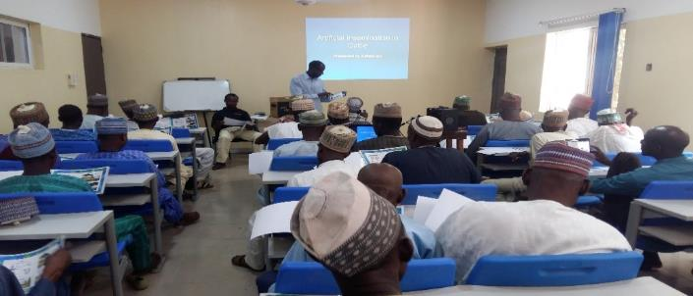
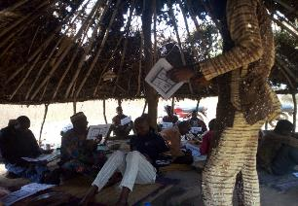
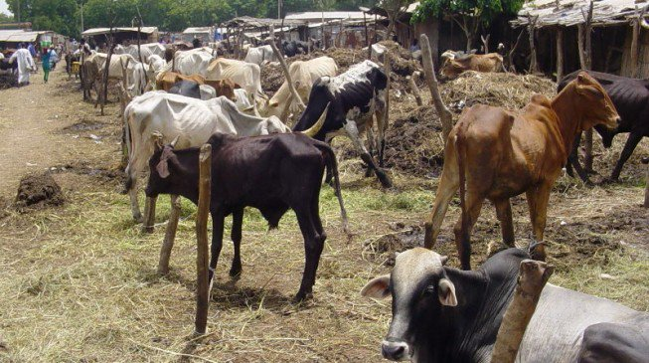
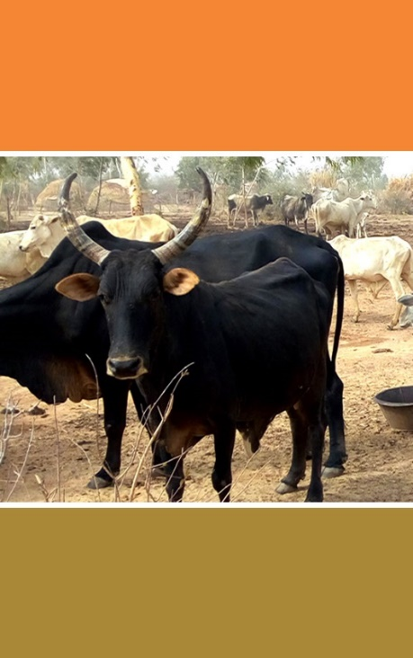

(insert company name)
ADVANCING LOCAL DAIRY DEVELOPMENT IN NIGERIA (ALDDN)
Proposal Template
June 2019
© Copyright 2019
Sahel Consulting Agriculture and Nutrition Limited
Confidential. Not for further reproduction or distribution
Introduction
The information you provide will be used to make an informed assessment about whether Sahel Consulting can enter into a partnership agreement with your organization on the Advancing Local Dairy Development in Nigeria (ALDDN) program. We will not be able to assess your suitability for partnership if you do not provide the information requested in this form. Please note that any partnership is dependent on the approval of the program by the funding organization.
Part 1: Corporate Information
Section A – Organisation details
Name of Organisation:
Organisation Headquarters Address/Main Office (and Registered Office, if different):
Office location(s) in Nigeria (if different from above):
Website for Organisation:
Copy of Legal Registration Certificate | Enclosed
Copy of Company’s TIN Certificate | Enclosed
Copy of Valid tax Compliance Certificate | Enclosed
Name and Position of Contact Person
Valid ID Card of the authorized person | Enclosed
Name and Role/Position of the person completing the proposal (if different from the person named above). Insert ‘N/A’ if there is no difference.
Section B – Company Overview
(Provide a company overview including its vision, mission, and service areas)
Section C – Owner/Managing Director/Executive Director Country Head details
Full Legal Name of the Owner/Managing Director/Executive Director/Country Head (As written on passport or national identification card)
Address of Owner/Managing Director/Executive Director/Country Head
Government Issued Means of Identification: | ID Number: | Nationality: |  |  | Date of Birth
Email: |  |  |  | Phone:
Section D – Board details (if applicable)
Names of Board Members (Including title e.g. Mr./Mrs./Ms.) | Status  (Executive/Non-Executive) | Profile  (Qualification(s), Designation, Organization)
Section E – Leadership Team Details
Nigeria Leadership Team
Names (Including title e.g. Mr./Mrs./Ms.) | Designation | Qualification(s)
Headquarters Representative (international organizations should provide the name of the representative at their headquarters who would provide oversight on the program)
Names (Including title e.g. Mr./Mrs./Ms.) | Designation | Qualification(s)

Part 2: Technical Proposal
Section A: Program Component Areas (Tick the one you are applying for)
Component | Intervention Areas | Your Selection
1 | - Identification of 20,000 dairy households in target states  - Organization of integrated farmers into Self-Help Groups and strengthening of the Self-Help Groups  - Provision of financial inclusion services and income diversification support to integrated dairy farmers
2 | - Production and sale of feed and fodder to integrated dairy farmers
3 | - Artificial Insemination and Animal Health
4 | - Policy advocacy to support a thriving dairy sector

Section B: Capability Statement
(Why is your organization best positioned to provide the services selected in the component(s) areas of interest selected above?)

Section C: Implementation Approach
(Provide details on how you propose to implement the selected interventions under the components of interest)

Section D: Outcome & Impact Indicators
(Outline the expected outcomes and key impact indicators that will be tracked for each intervention)
Expected Outcomes | Indicators
Section E: Workplan
(Provide a narrative in the box below and use the accompanying excel template to provide a breakdown of key activities, outputs and annual timeline as described in your proposed approach)
Section F: Risk Matrix
Risks | Probability of Occurrence  (High, Medium, or Low) | Potential Impact  (High, Medium, or Low) | Mitigation Strategies
Part 3: Price Proposal
(Provide a narrative in the box below and use the accompanying excel template to provide a breakdown of projected costs for executing tasks outlined in the workplan)

Part 4: Past Experience
Section A: Experience in Selected Intervention Areas
Include at least three (3) examples of current or past projects (and references associated) that clearly highlight the experience in delivering similar scope of work with the interventions under the component you are applying for using the tables below.
Name of Project
Location of Project
Start Date – End Date:
Contract Amount:
Description of Services Provided:
Reference Contact Name:
Reference Contact Number:
Reference Contact Address:
Reference Email Address:

Name of Project
Location of Project
Start Date – End Date:
Contract Amount:
Description of Services Provided:
Reference Contact Name:
Reference Contact Number:
Reference Contact Address:
Reference Email Address:

Name of Project
Location of Project
Start Date – End Date:
Contract Amount:
Description of Services Provided:
Reference Contact Name:
Reference Contact Number:
Reference Contact Address:
Reference Email Address:

Section B: Experience in Gender & Nutrition
Provide details of the organizations experience in implementing programs that promote gender and/or nutrition-related issues
Name of Project
Location of Project
Start Date – End Date:
Contract Amount:
Description of Program:
Reference Contact Name:
Reference Contact Number:
Reference Contact Address:
Reference Email Address:

Section C: Experience in Livestock/Dairy
Provide details of the organizations experience in implementing programs in the dairy/livestock sector
Name of Project
Location of Project
Start Date – End Date:
Contract Amount:
Description of Program:
Reference Contact Name:
Reference Contact Number:
Reference Contact Address:
Reference Email Address:

Part 5: Personnel and Management
(List proposed personnel to be assigned to this program include the role and a bio for key personnel listed. Bios must include education, training, languages, key accomplishments, and relevant experience. All key personnel should be indicated in the Proposal and their commitments confirmed.)
Name | Role | Bio
(Include CVs of personnel listed above as separate attachments)
Part 6: Certification
I hereby certify that;
To the best of my knowledge, all information in this response is truthful, correct and complete.
Signature:
Name:
Title/Position:
Date:

